Gallery

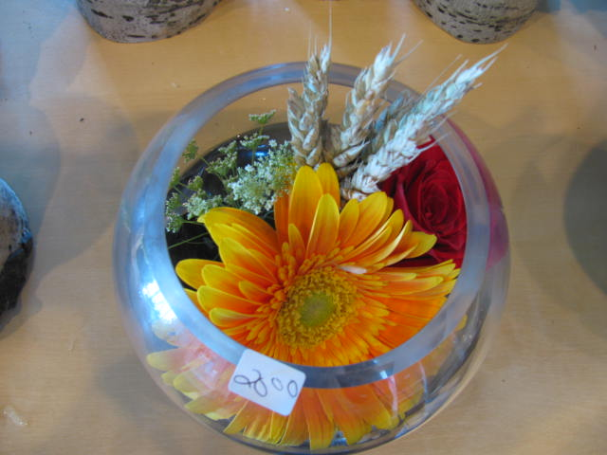

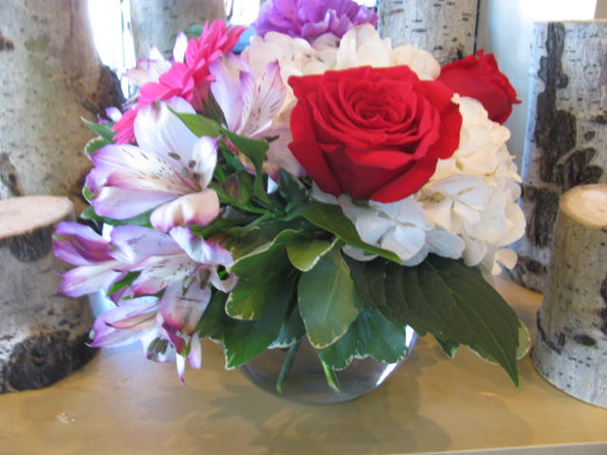

**Small Rose Bowl $20.00**

**Summer Cheer $50.00**

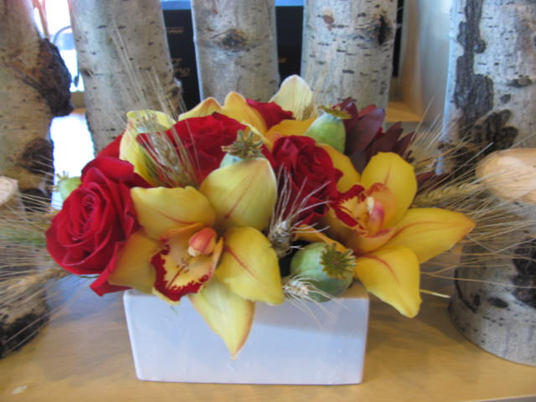

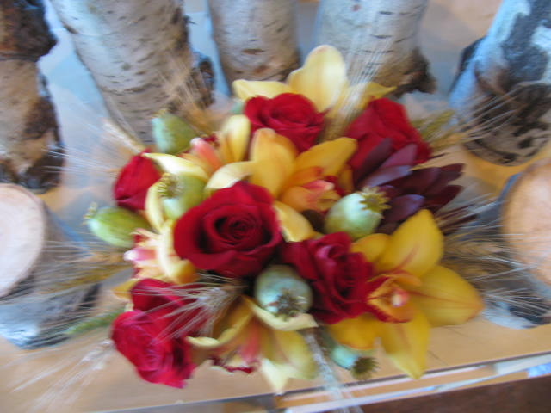

$100.00 Arranged Orchids & Roses

$100.00 Arranged Orchids & Roses

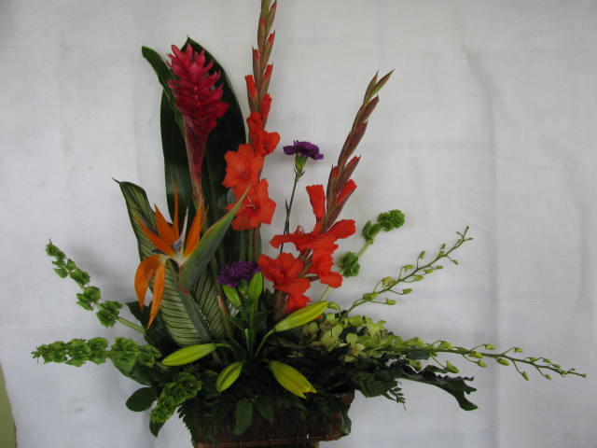

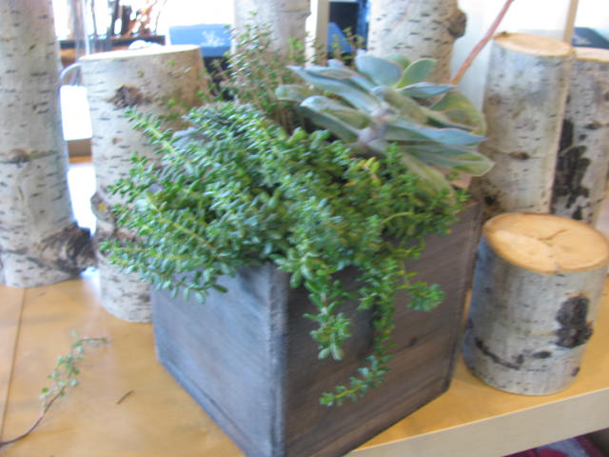

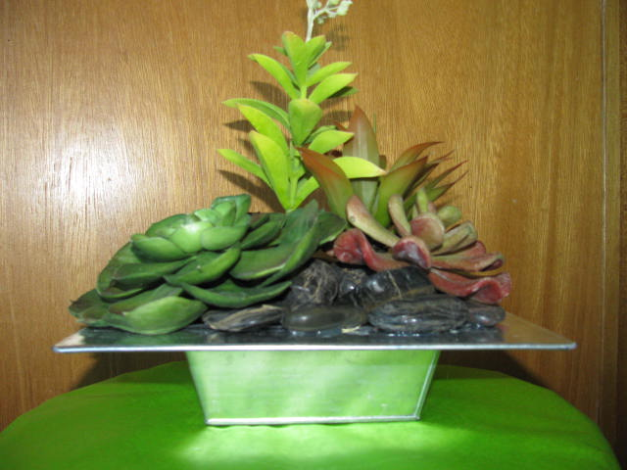

$49.00 Planter

$49.00 Planter

$15.00 Fall Planter

$49.00 Planter

$50.00 Pre-Made Bunch

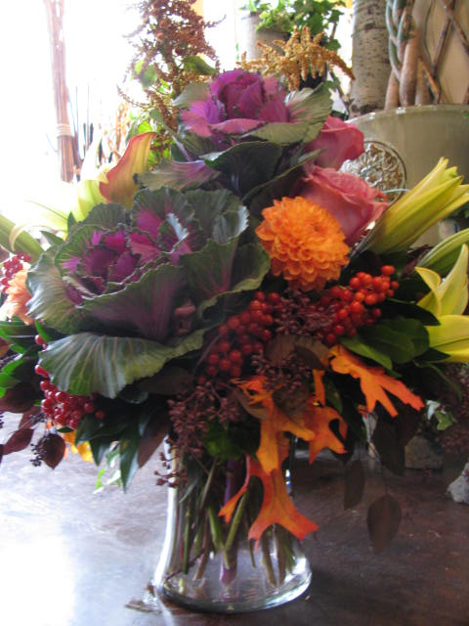

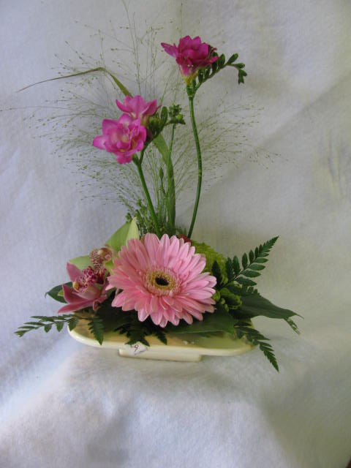

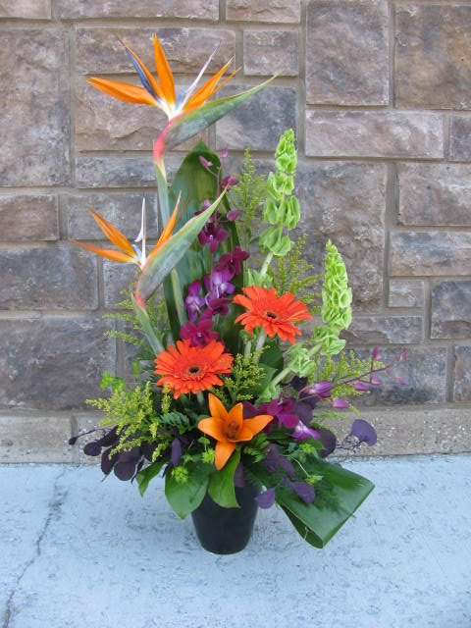



$65.00 Exotic Arrangement



$.00 summer Vase

$200.00 Fall Vase

$40.00 Pre-Made Bunch

$30.00 Pre-Made Bunch

$25.00 Pre-Made Bunch

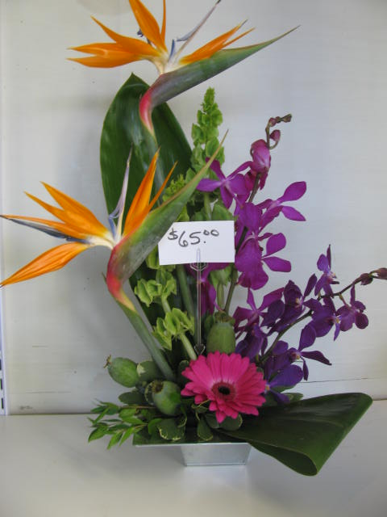









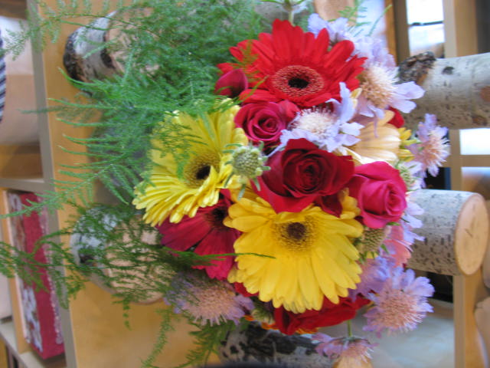



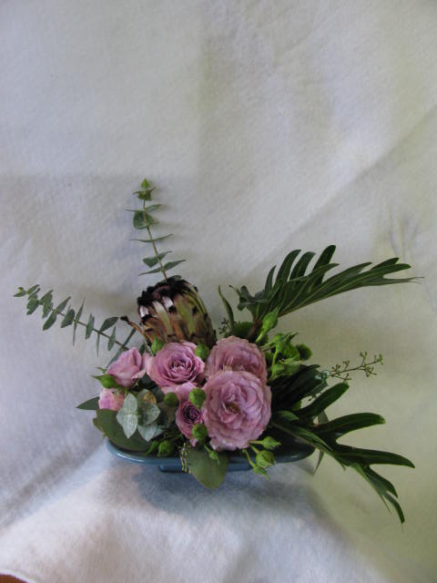

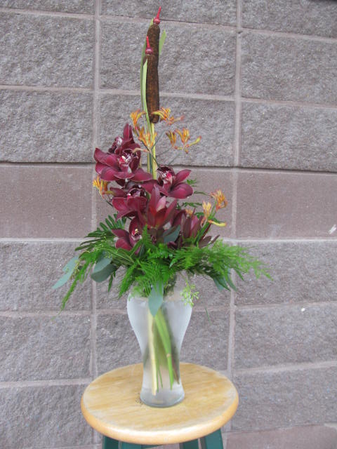



$45.00 Arrangement

$50.00 Arrangement

$25.00 Arrangement

$30.00 Arrangement

$ 55.00 Macara Arrangement

$ .00 Arrangement

$35.00 Arrangement

$25.00 Arrangement

$ .00 Arrangement

